# Assignment -4

|  |  |
| --- | --- |
| Assignment Date | 31 oct 2022 |
| Student Name | Abarjitha.R |
| Student Roll Number | 811019106002 |
| Maximum Marks | 2 Marks |

**Question:**

**Write code and connections in wokwi for ultrasonic sensor. Whenever distance is less than 100 cms send "alert" to ibm cloud and display in device recent events.**

**Coding:**

#include <WiFi.h> #include <PubSubClient.h>

WiFiClient wifiClient; String data3;

#define speed 0.034

#define led 15

const int trigpin=13; const int echopin=12; String command; String data="";

long duration; float dist;

//-------credentials of IBM Accounts------

#define ORG "2cn649"

#defineDEVICE_TYPE"abarjithadevice" #defineDEVICE_ID”abarjithadeviceid”

#define TOKEN “3mxPrNZUis6BlD0wOo”

//-------- Customise the above values --------

char server[] = ORG ".messaging.internetofthings.ibmcloud.com"; char publishTopic[] = "iot-2/evt/Data/fmt/json";

char topic[] = "iot-2/cmd/command/fmt/String"; char authMethod[] = "use-token-auth";

char token[] = TOKEN;

char clientId[] = "d:" ORG ":" DEVICE_TYPE ":" DEVICE_ID;

PubSubClient client(server, 1883, wifiClient); void publishData();

void setup()

{

**Serial**.begin(115200); pinMode(led, OUTPUT); pinMode(trigpin, OUTPUT); pinMode(echopin, INPUT); wifiConnect(); mqttConnect();

}

void loop()

{

bool Nearby = dist < 100; digitalWrite(led, Nearby);

publishData(); delay(500);

if (!client.loop())

{

mqttConnect();

}

}

void wifiConnect()

{

**Serial**.print("Connecting to "); **Serial**.print("Wifi"); WiFi.begin("Wokwi-GUEST", "", 6); while (WiFi.status() != WL_CONNECTED)

{

delay(500);

**Serial**.print(".");

}

**Serial**.print("WiFi connected, IP address: ");

**Serial**.println(WiFi.localIP());

}

void mqttConnect()

{

if (!client.connected())

{

**Serial**.print("Reconnecting MQTT client to ");

**Serial**.println(server);

while (!client.connect(clientId, authMethod, token))

{

**Serial**.print("."); delay(500);

}

initManagedDevice();

**Serial**.println();

}

}

void initManagedDevice()

{

if (client.subscribe(topic))

{

// Serial.println(client.subscribe(topic));

**Serial**.println("IBM subscribe to cmd OK");

}

else

{

**Serial**.println("subscribe to cmd FAILED");

}

}

/*....................................retrieving to

Cloud */

void publishData()

{

digitalWrite(trigpin,LOW); digitalWrite(trigpin,HIGH); delayMicroseconds(10); digitalWrite(trigpin,LOW); duration=pulseIn(echopin,HIGH); dist=duration*speed/2; if(dist<100)

{

String payload = "{\"Alert Distance is \":"; payload += dist;

payload += "}";

**Serial**.print("\n"); **Serial**.print("Sending payload: "); **Serial**.println(payload);

if (client.publish(publishTopic, (char*) payload.c_str()))

{

**Serial**.println("Publish OK");// if it sucessfully upload data on the cloud then it will print publish ok in Serial monitor or else it will print publish failed

digitalWrite(led,HIGH);

}

}

if(dist>100)

{

String payload = "{\"Distance is\":"; payload += dist;

payload += "}";

**Serial**.print("\n"); **Serial**.print("Sending payload: "); **Serial**.println(payload);

if(client.publish(publishTopic, (char*) payload.c_str()))

{

**Serial**.println("Cross the alert distance"); digitalWrite(led,LOW);

}

else

{

**Serial**.println("Publish FAILED");

}

}

}

void callback(char* subscribeTopic, byte* payload, unsigned int payloadLength)

{

**Serial**.print("callback invoked for topic:");

**Serial**.println(subscribeTopic); for(int i=0; i<payloadLength; i++)

{

dist += (char)payload[i];

}

**Serial**.println("data:"+ data3); if(data3=="lighton")

{

**Serial**.println(data3); digitalWrite(led,HIGH);

}

data3="";

}

# Connection:

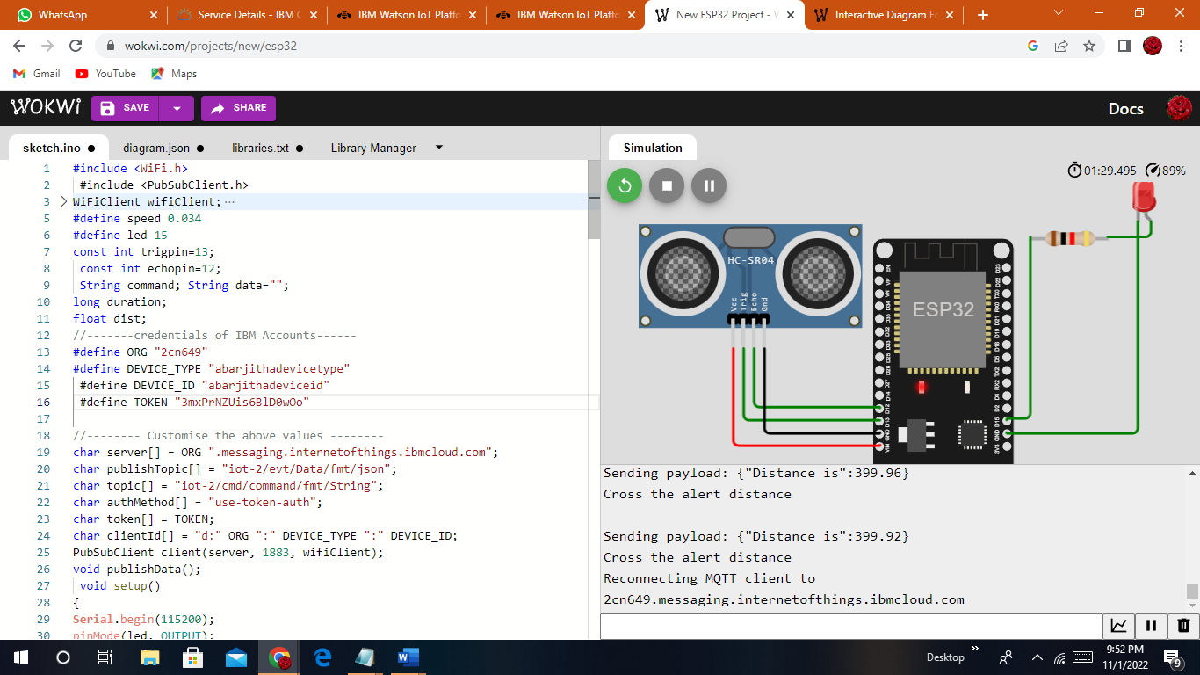

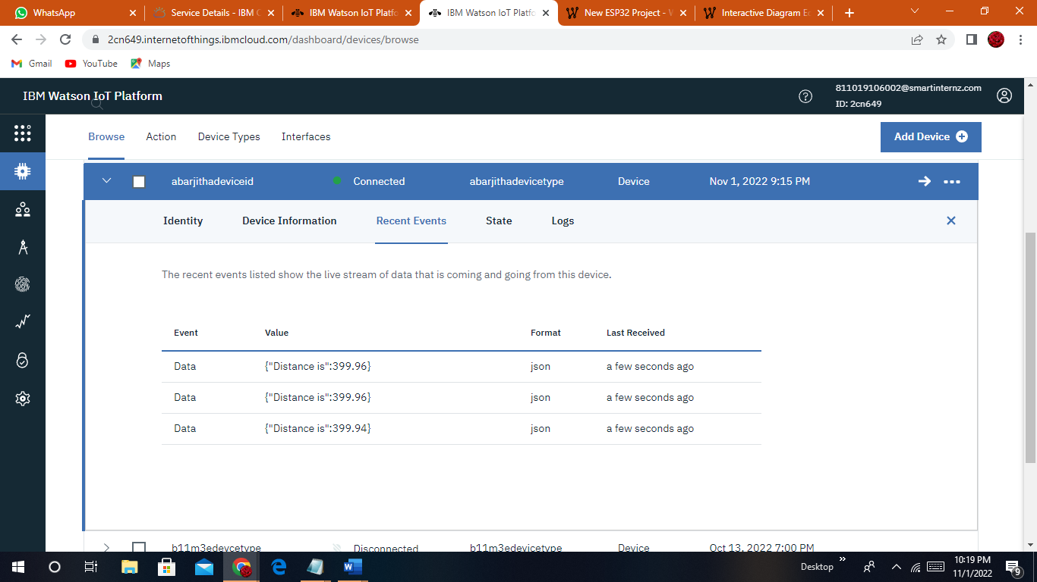

**Wokwi link:**

https://wokwi.com/projects/347177529453314644